Computer Language Conding Concepts

Inactive Command Class Redirection in a Diagram
The concept of inactive command class redirection is explained in the article Inactive Command Class Redirection. The current article explains its expression in a diagram.

Even though it is not allowed to use an inactive command class redirection, its usage only creates a warning and alternate behavior. You will be able to see an inactive command class redirection in a diagram, but it will be marked with a warning, and its behavior will be that of an inactive command object redirection.

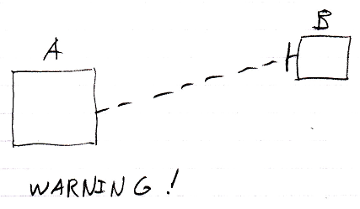

Refer to the article Inactive Command Object Redirection in a Diagram for an explanation of the behavior and meaning of the diagram above.

See also: Inactive Command Class Redirection,
Inactive Command Object Redirection in a Diagram,
Commands

Author & Copyright: Jan-Joost van Zon Date: August 10, 2008 – August 10, 2008 Location: Oosterhout, The Netherlands Status: Finished

